**Level 0: Context Diagram**

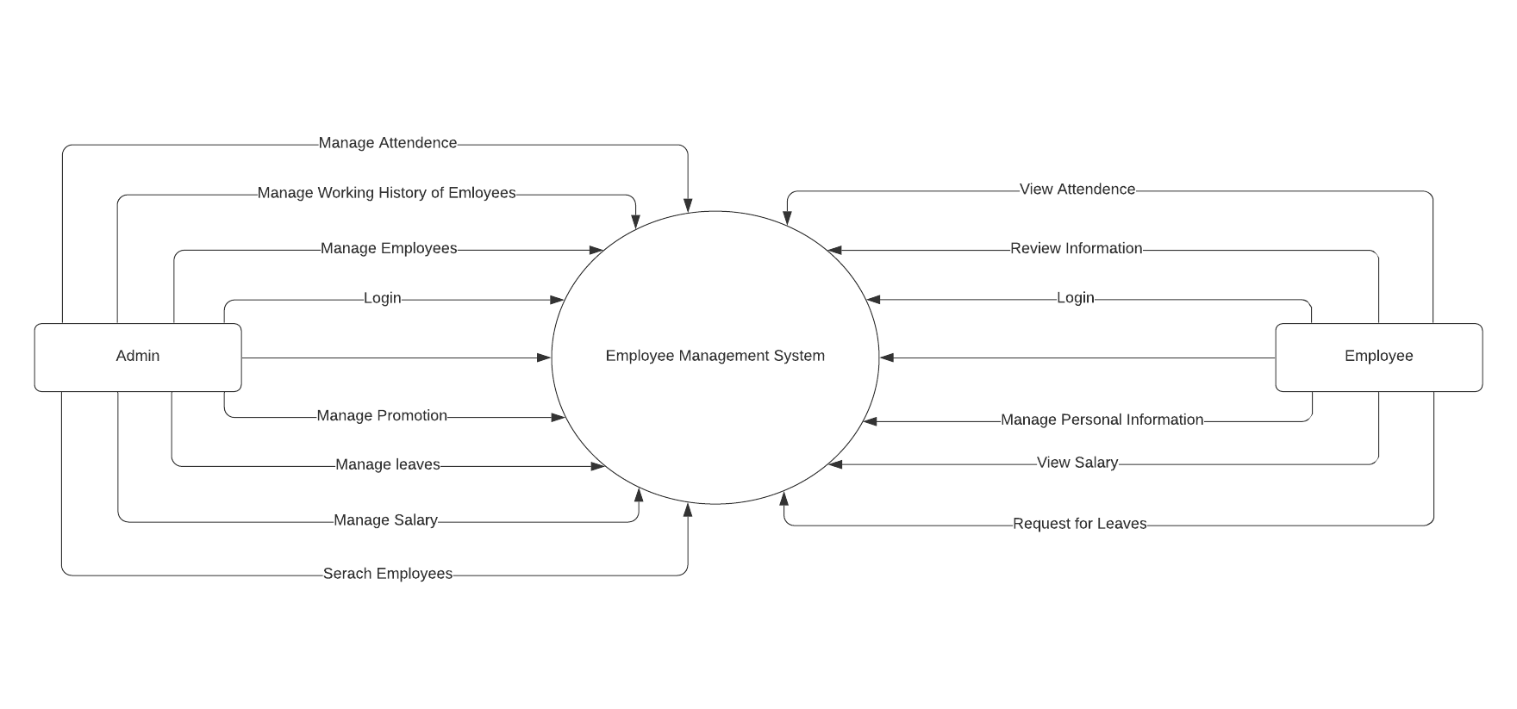

**Level 1: Overview Diagram**

**Level 1.1 – Login**

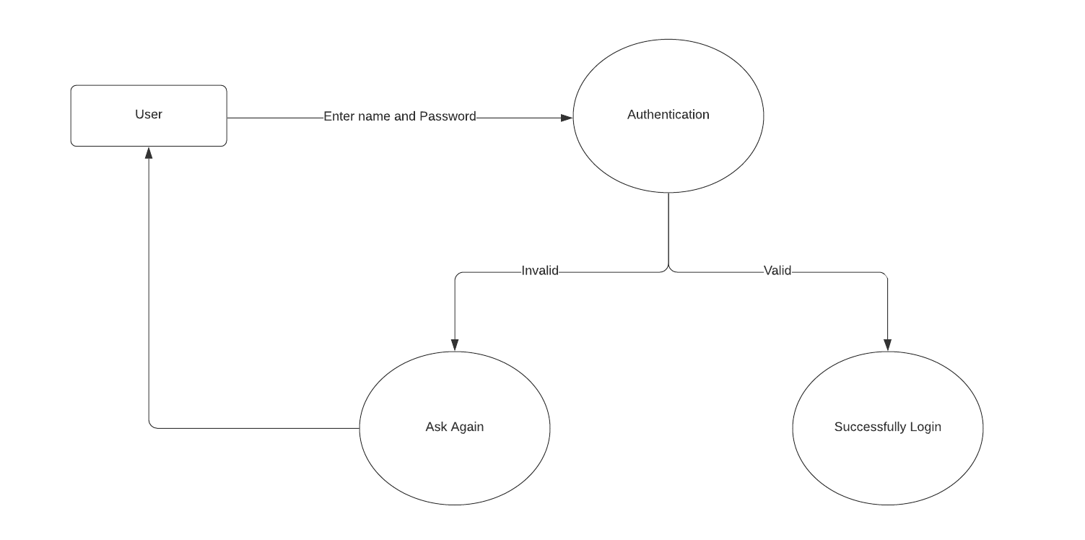

**Level 1.2 – Manage Employees**

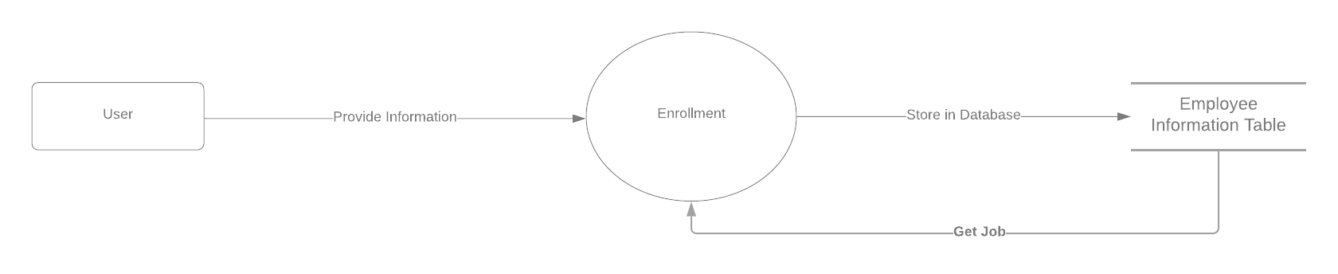

**Level 1.3 – Add Details**

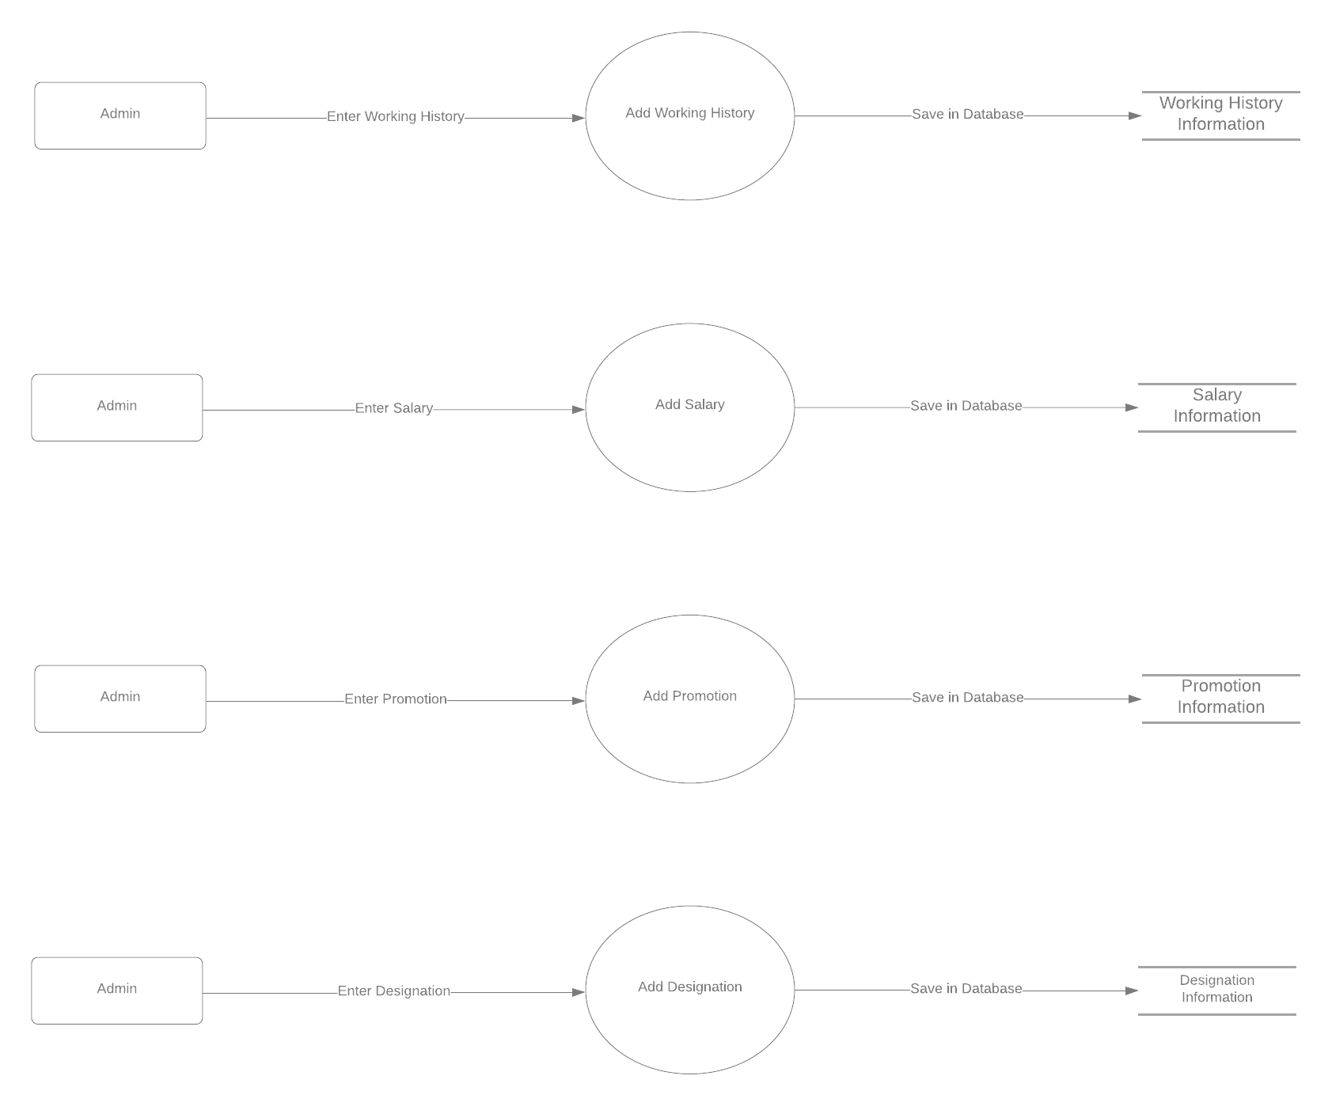

**Level 1.4 – Manage Attendance**

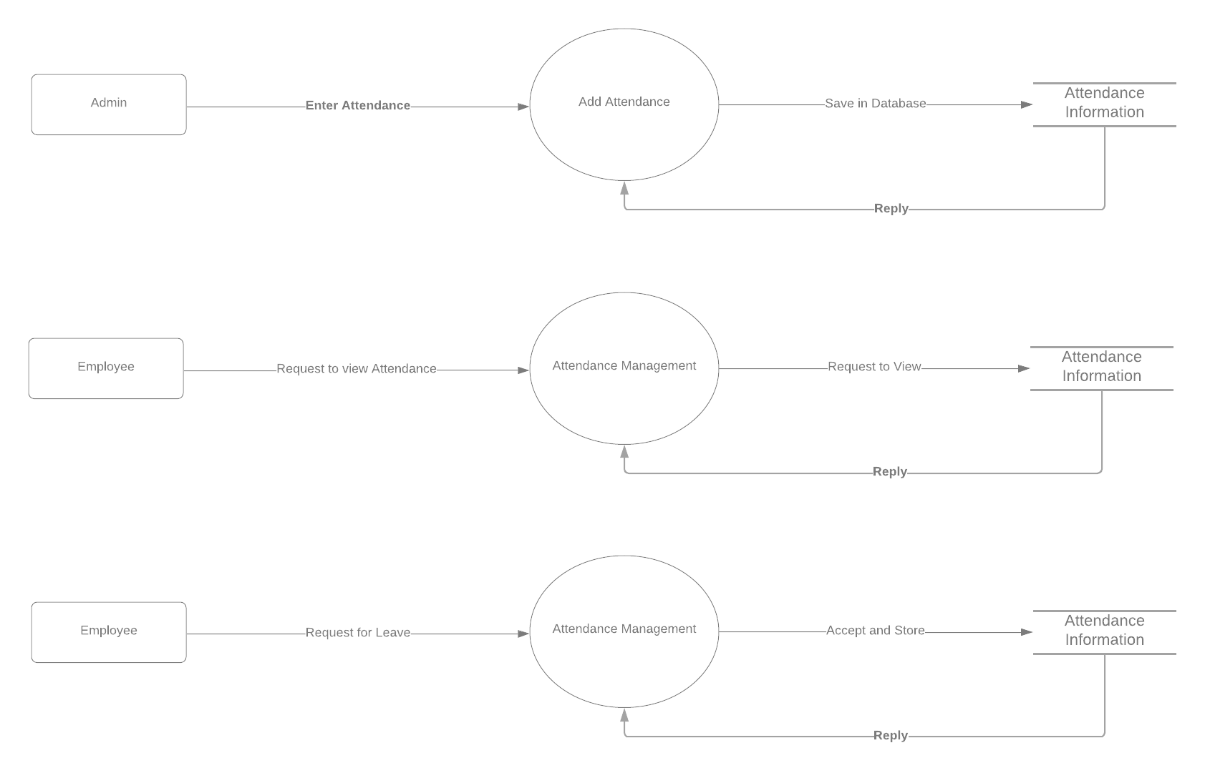

**Level 1.5 – Manage Personal Information**

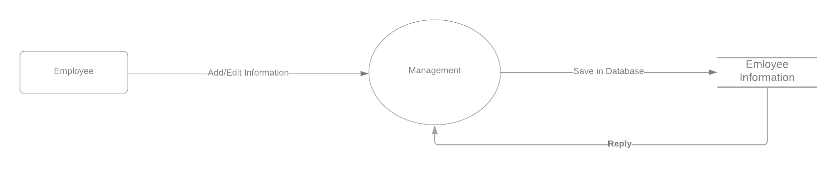

**Level 2: Detailed Diagram**

**Level 2.1 – Login**

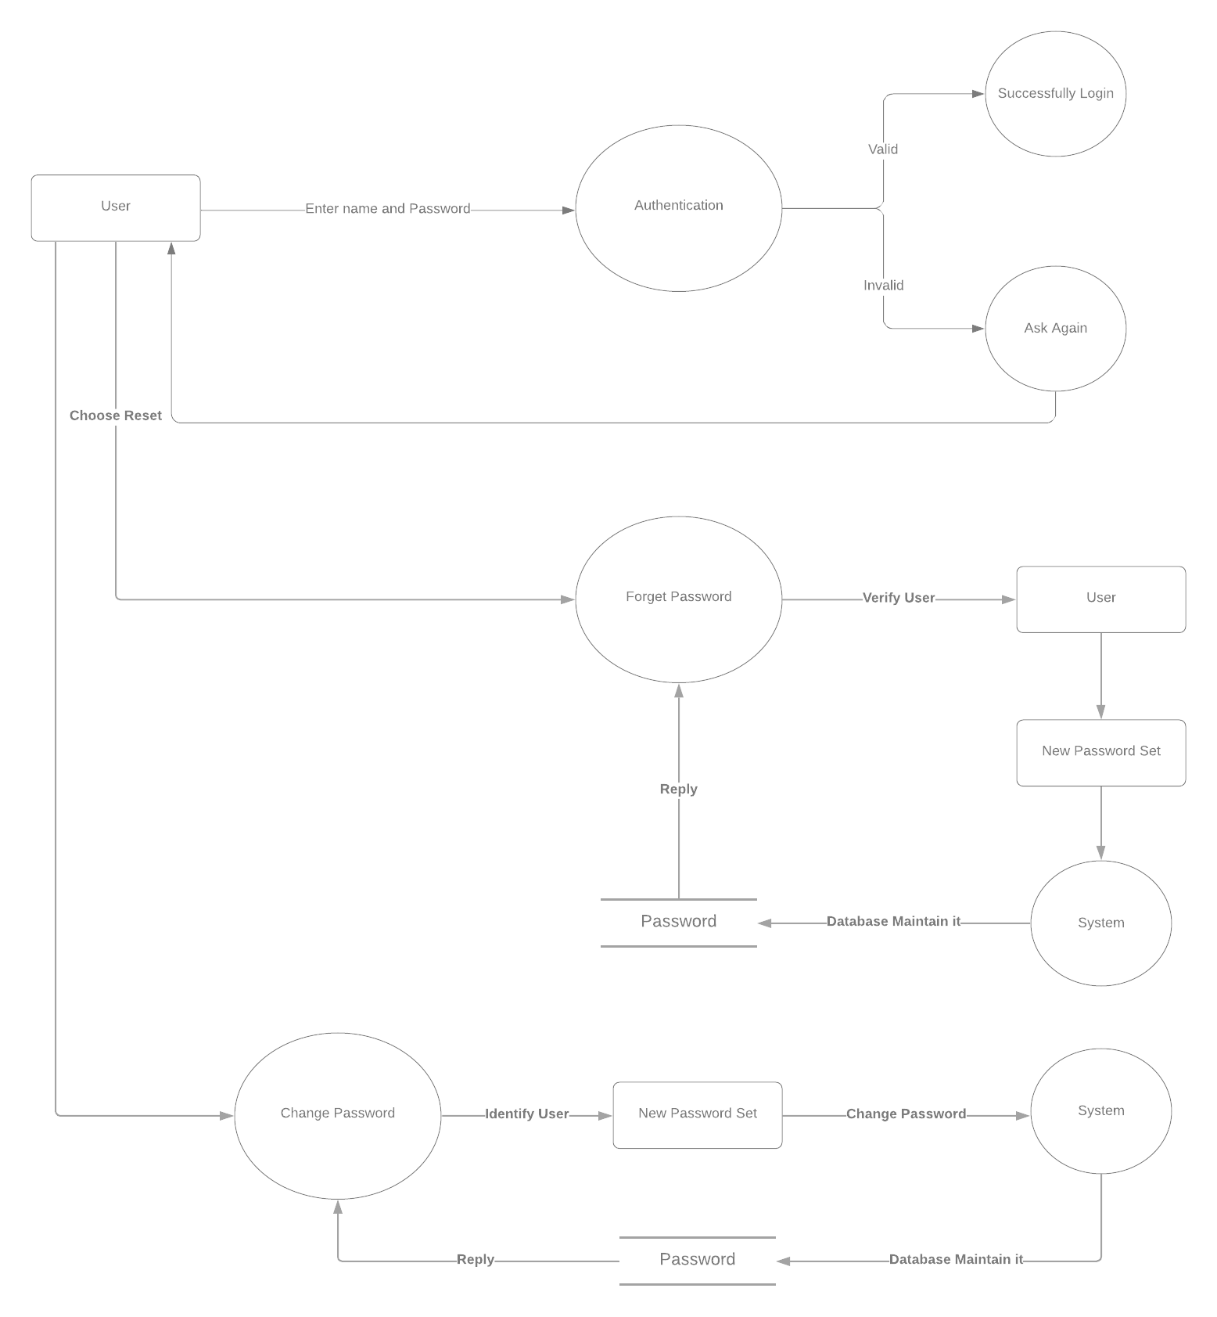

**Level 2.2 – Manage Employees**

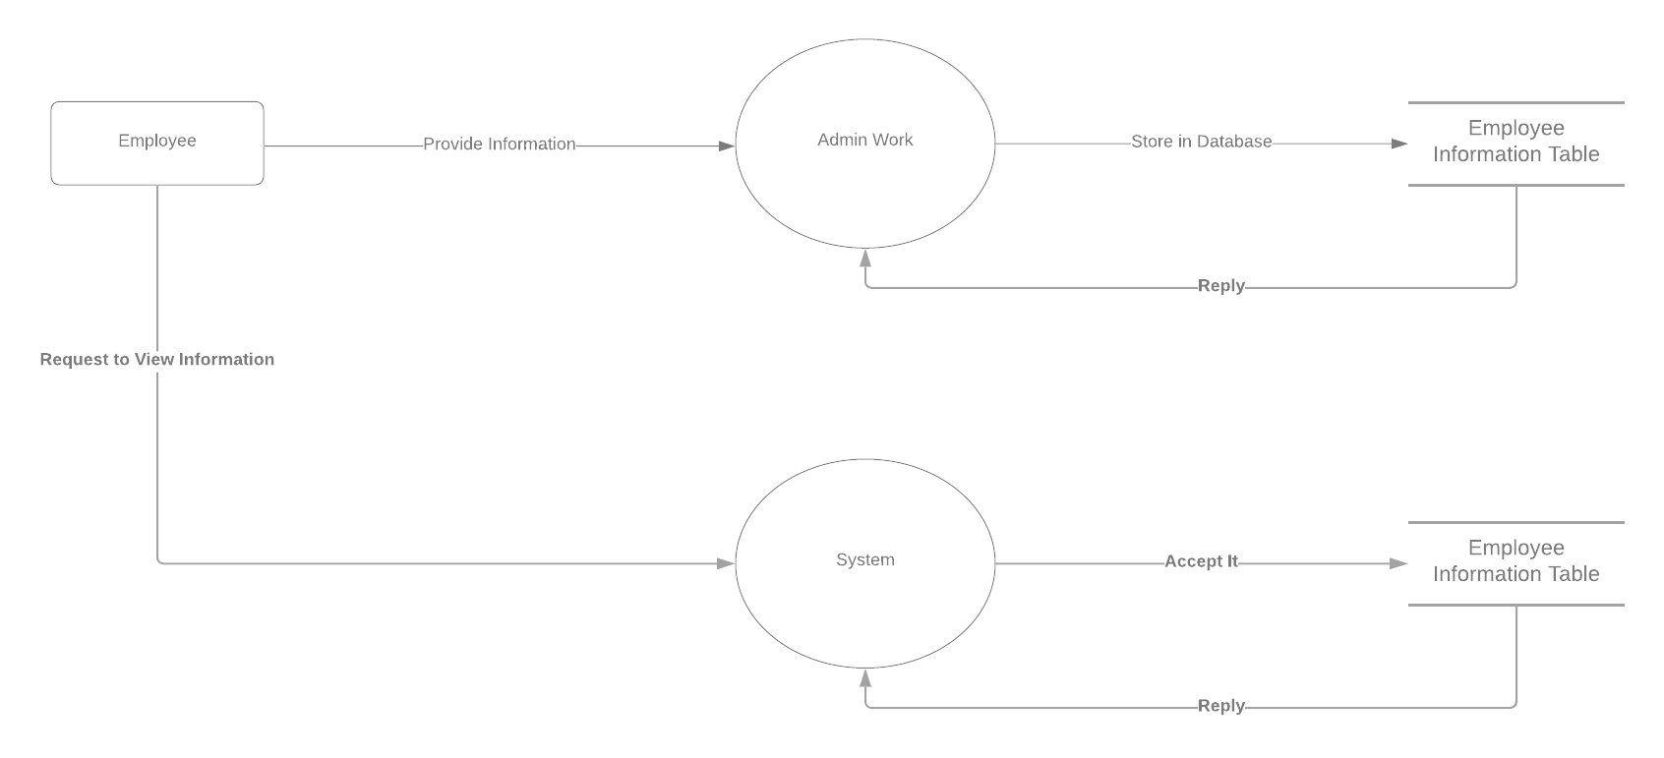

**Level 2.3 – Add Details**

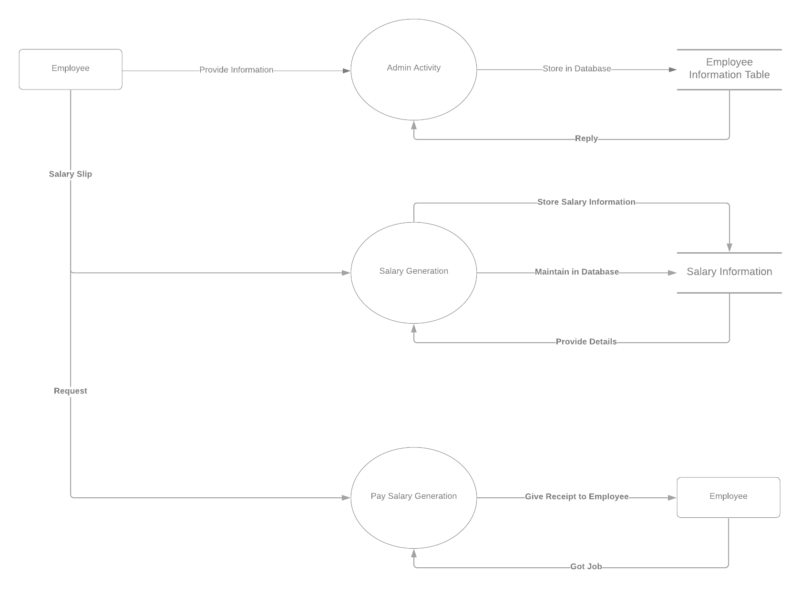

**Level 2.4 – Manage Attendance**

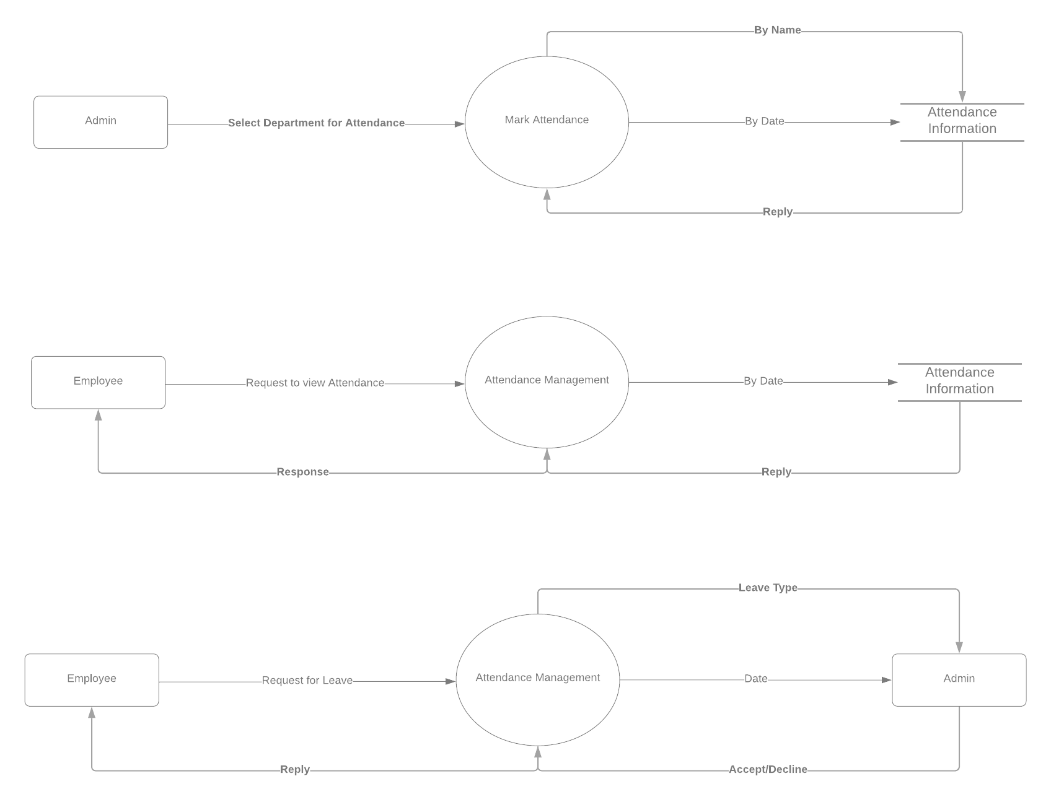

**Level 2.5 – Manage Personal Information**

